Nate Howe

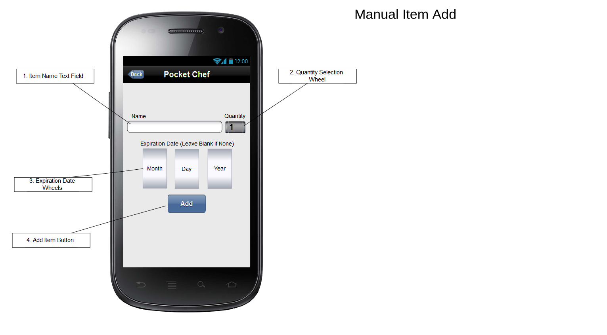 Group 10

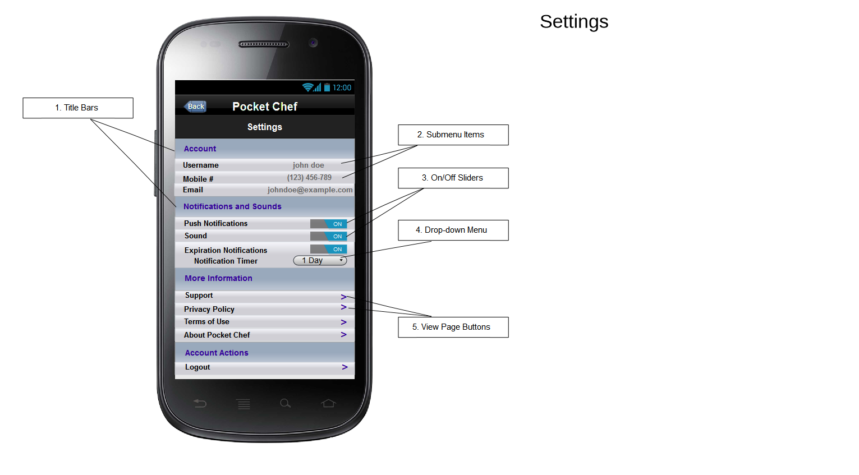

The “Settings” page allows a user to modify application settings and preferences. There are several groups of settings, listed as title bars (1), a user is able to modify, varying from account to notification settings. Some submenu items (2) are simple text, but others have on/off sliders (3), drop-down menus (4), or view page buttons (5). From this page, users can also view miscenlaneous information, such as the privacy policy, terms of use, and support. Also, a user can logout using this page, or change their personal information.

The "Manual Item Add" page allows a user to add an item to their inventory manually. To add an item, the user enters a name into the name text field (1), selects the quantity of the item with the quantity selection wheel (2), and (optional) selects an expiration date using the date wheels (3). Finally, the user can add the item to their inventory by clicking the “Add” button (4).